- Identify and describe the three key elements of an entrepreneurial orientation (EO). Discuss how a company that manifests an entrepreneurial orientation differs from a traditional corporate organization? In order for an organization to be identified as entrepreneurial, must it score high on all three aspects of EO? Why or why not?
- Identify and describe the different forms that corporate entrepreneurship can take, distinguishing between corporate venturing and strategic entrepreneurship. What are some of the unique challenges of corporate venturing? Include a discussion of challenges associated with researching and understanding corporate venturing
- What is the difference between an “entrepreneurial strategy” and a “strategy for entrepreneurship”? How are both enacted in an organization?
- Imagine yourself as a consultant to an organization that recognizes a need to become more entrepreneurial. This organization is structured as a “machine bureaucracy” and is unwilling to make changes to its formal structure. What can you recommend within the constraints of a bureaucratic organization that will promote more entrepreneurship?
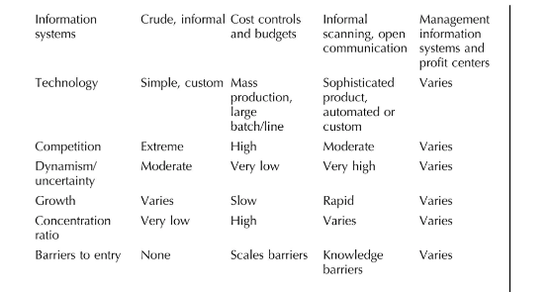
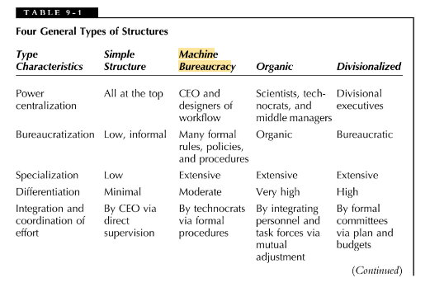
for question 4

References
Morris, M. H., Kuratko, D. F., & Covin, J. G. (2010). Corporate entrepreneurship & innovation 3rd ed. Cengage Learning.

